Question#1

#include<iostream>

using namespace std;

int main ()

{

int nth,x;

float ans=0, sum=0;

cout<<"input value for nth term: "<<endl;

cin>>nth;

for(x=1;x<=nth;x++)

{

ans=1/(pow(x,x));

cout<<endl<<"1/"<<x<<"^"<<x<<"="<<ans<<endl;

sum=sum+ans;

}

cout<<"the sum of the above series is: "<<sum<<endl;

system ("pause");

return 0;

}

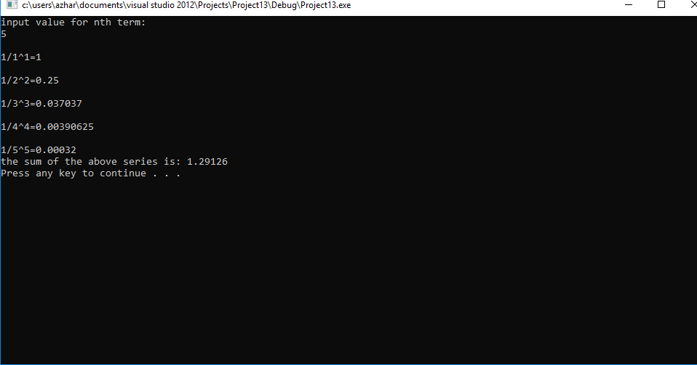

Question#2

#include<iostream>

using namespace std;

int main ()

{

int num,m,ans=0,limit=10;

cout<<"input the number: ";

cin>>num;

for(m=1;m<=limit;m++)

{

ans=num\*m;

cout<<num<<"x"<<m<<"="<<ans<<endl;

}

system ("pause");

return 0;

}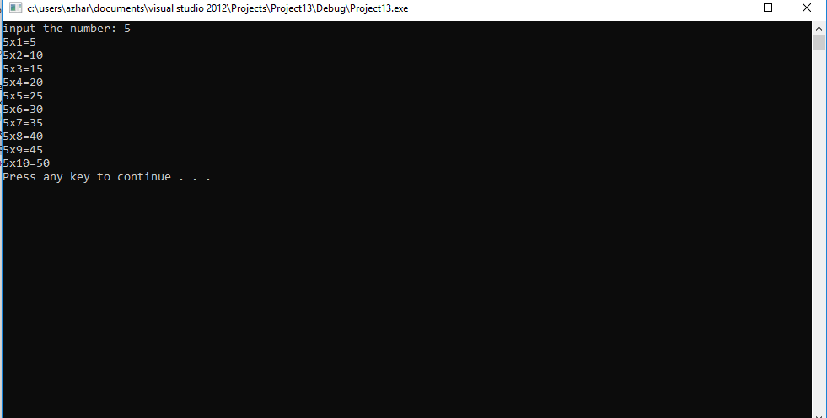

Question#3

#include<iostream>

using namespace std;

int main ()

{

int terms,x,even=0,sum=0;

cout<<"input number of terms: "<<endl;

cin>>terms;

cout<<"the even number of term: "<<endl;

for(x=1;x<terms+1;x++)

{

even=even+2;

cout<<even<<" ";

sum=sum+even;

}

cout<<"the sum of even natural number upto"<<terms<<"terms: "<<sum<<endl;

system ("pause");

return 0;

}

Question 4

#include<iostream>

using namespace std;

int main ()

{

float val1,val2,soln;

char op,cont;

do

{

cout<<"enter the value 1: ";

cin>>val1;

cout<<"enter the value 2: ";

cin>>val2;

cout<<endl<<"=====List of operations====="<<endl;

cout<<"press + for addition"<<endl;

cout<<"press - for subtraction"<<endl;

cout<<"press \* for multiplication"<<endl;

cout<<"press / for division"<<endl;

cout<<"=========================="<<endl;

cin>>op;

switch (op)

{

case '+':

soln=val1+val2;

cout<<"addition: "<<soln<<endl;

break;

case '-':

soln=val1-val2;

cout<<"subtraction: "<<soln<<endl;

break;

case '\*':

soln=val1\*val2;

cout<<"multiplication: "<<soln<<endl;

break;

case '/':

soln=val1/val2;

cout<<"division: "<<soln<<endl;

break;

default:

cout<<"the operation entered is invalid: "<<endl;

}

cout<<"do you want to continue(y/n)?"<<endl;

}

while(cont!='n');

system ("pause");

return 0;

}